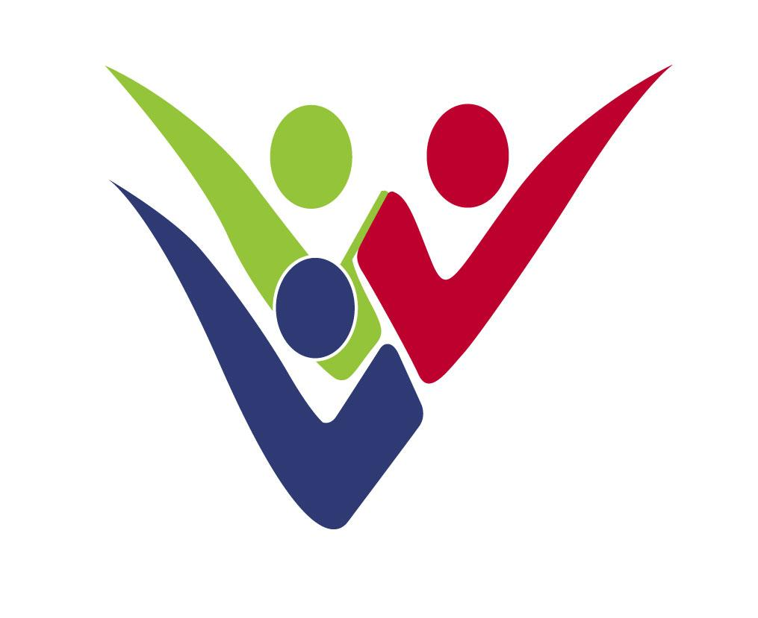
DEPARTMENT FOR SOCIAL INCLUSION OF PERSONS WITH DISABILITIES
1430 NICOSIA

REPUBLIC OF CYPRUS

MINISTRY OF LABOUR, WELFARE
AND SOCIAL INSURANCE

ANNUAL REPORT 2020
DEPARTMENT FOR SOCIAL INCLUSION OF PERSONS WITH DISABILITIES

The Department for Social Inclusion of Persons with Disabilities (DSID) has been established as from 1/1/2009, as a new Department of the Ministry of Labour, Welfare and Social Insurance, according to Decision of the Council of Ministers no. 66.763 dated 6/2/2008 and the State Budget Law for 2009.

The aim of the Department is the promotion of social protection, social inclusion and employment of persons with disabilities. The vision of the Department is the improvement of quality of life of persons with disabilities and the creation of new prospects for social inclusion through the formulation, coordination and implementation of reforms.

The organisational structure of the Department is based on four sectors: a) Management of the System for the Assessment of Disability and Functioning, b) Social Benefits, c) Support Services and Vocational Rehabilitation and d) Focal Point for the implementation of the UN Convention for the Rights of Persons with Disabilities. In addition the Department chairs the Special Fund of the Vocational Training and Rehabilitation Centre and the Executive Board of the Christos Stelios Ioannou Foundation.

1. Management of the System for the Assessment of Disability and Functioning

The project “Expansion of the Implementation of the New System for the Assessment of Disability and Functioning” is implemented by DSID in the programming period 2014-2020 through financing by the European Social Fund with a total budget of €4,2 m. The project consists an expansion of the previous project implemented in the period 2007-2013 for the introduction of the new disability assessment system with a cost of €1,8 m. As from December 2013 the first Disability Assessment Center operates in Nicosia and from May 2017 the second Center operated in Limassol. An additional Center is expected to operate in Larnaca in 2021. A new proposal for further expansion and upgrading of the Disability Assessment System was approved for the new programming period 2021-2027.
Through the new system the disability and the needs of the applicant are assessed by multidisciplinary committees and the citizen receives a holistic report on the rights for social benefits and services that is entitled to. The assessment results are input in the national disability data base that is gradually created aiming to support the formulation of targeted policies of the state relating to disability.
2. Social Benefit Schemes for Persons with Disabilities

The main Social Benefit Schemes of the Department are the following:

- Severe motor disability allowance: Persons with severe motor disabilities are entitled a monthly allowance of €346,27 (At 31.12.2020, 2.186 persons were entitled to this allowance and the cost for 2020 was €9.287.853)
- Care allowance for persons with paraplegia or tetraplegia of €400 or €500 monthly for persons with paraplegia and €900 or €1100 monthly for persons with tetraplegia(At 31/12/2020: 1059 beneficiaries with paraplegia with a cost at €5.691.896 and 797 beneficiaries with tetraplegia with a cost at €9.411.396)
- Special Allowance for Blind Persons of €324,43 monthly (At 31/12/2020: 1.985 beneficiaries with a cost for 2020 at €8.142.165)
- Mobility Allowance of €75- €150 monthly (At 31/12/2020: 3.938 beneficiaries with a cost for 2020 at €4.667.692)
- Financial Assistance for persons with disabilities in order to buy a car (In 2020: 392 beneficiaries with a cost for 2020at €1.657.023)
- Financial assistance for the provision of technical aid (In 2020: 1.041 beneficiaries with a cost for 2020 at €1.359.357)
- Financial assistance for the provision of wheel chairs (In 2020: 431 beneficiaries with a cost for 2020 at €1.425.745).
- The scheme for providing the Blue Badge i.e. the card for facilitating parking for persons with disabilities continued to operate.
- The scheme for providing the European Disability Card, based on a European project with the participation of 8 EU member states. The special website for the Card is www.eudisabilitycard.gov.cy (for 2020: 834 new beneficiaries of the Card)
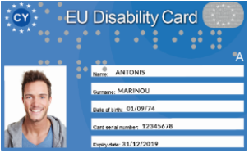

3. Support Services and Vocational Rehabilitation

2020 was a milestone for the Department’s provision of support services to persons with disabilities. The main projects and actions in this sector were the following:

- In the framework of the Ministry’s policy the Department implemented the project financed by the European Social Fund concerning the “Operation of new houses/programmes for supported living in the community for persons with disabilities” Through public procurement the Department signed public contracts with Contractors from the private sector being NGO’s, companies or professionals and in March 2020 seven new houses operated in almost all cities of Cyprus and became home for 28 persons with intellectual disability (6 houses) and 4 persons with visual disability (1 house). The Department of Social Inclusion of Persons with Disabilities announced an additional public procurement competition in 2020 for four more houses for 5 persons with intellectual disability and 8 persons with autism and signed contracts on February 2021. People with disabilities enjoy in these small family-type homes a safe, dignified and quality living with the necessary support services in the fields of care, communication, entertainment, skills development, socialization. Further expansion of the project was approved during the new programming period 2021-2027.

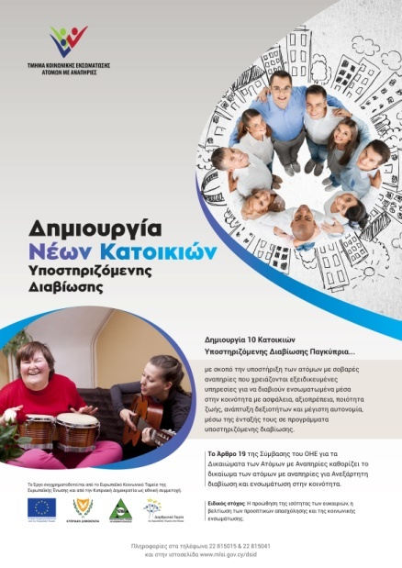

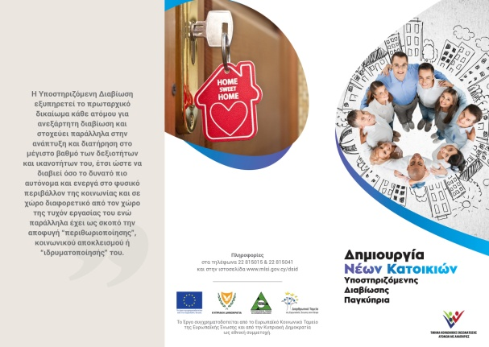

- With the decision of the Council of Ministers no. 87,345 on 6th of May2019, the creation and operation of the Family Intervention and Support Center for Autism was approved as a project co-financed by the European Social Fund for the programming period 2014-2020. In 2020 a new public procurement competition was announced by the Department and the renovation of the buildings to house the Center was completed. The creation and operation of the Center aims at the timely provision of intervention and support services, so that children with autism participate in all aspects of social life. At the same time, the aim of the project is to maintain family cohesion, a necessary element both for the wider social cohesion and prosperity but also for the progress of the children themselves. The mission of the Center is to provide specialized services to children up to the age of compulsory education, who have been diagnosed with autism, as well as to their families, such as: (a) Psychological Support, Counseling and Psychoeducation Service, (b) Home Training and Support Service for the child and the family in the context of early childhood intervention specifically focused on children with Autism Spectrum Disorders, (c) Social Support Service. The Center will be able to serve and provide its services to about 300 children and their families annually across Cyprus.
- Financial assistance to the organisations of persons with disabilities for coverage the expenses of the operation of social programs (16 organisations were subsidized with a cost in 2020 of €76.563,49. The Confederation of the Organisations of Disabled People also receives an annual grant for almost all its expenses (€70.000 for 2020).
- Subsidisation of organisations of persons with severe disabilities to recruit and manage Social Assistants for their members in order to support them at visiting state services, hospitals and doctors, banks, day care programmes, shopping, recreation activities etc (7organisations were subsidized for 1.160 beneficiaries with disabilities and a cost for 2020 of €149.646,74).
- Presidency of Executive Board of the Christos Stelios Ioannou Foundation by the Director of the Department who represents at the Board the Director General of the Ministry of Labour, Welfare and Social Insurance. Since 2020 the annual financial subsidy for the Foundation has been moved from the Ministry of Finance to the Ministry of Labour, Welfare and Social Insurance. The most important actions in 2020 were the formulation of the first Strategic Plan of the Foundation's work, the completion of its staff vacant posts with new scientific personnel, the expansion and enrichment of creative employment and therapeutic and social rehabilitation, renovation and modernization of the operation the Foundation.

The main Vocational Rehabilitation Programmes and Schemes provided by the Department are the following:

- The Department is responsible to support and monitor the implementation of the Recruitment of Persons with Disabilities in the Wider Public Sector Law which is a special law forcing all public services to recruit up to a quota of 10% of their vacant posts, persons with disabilities who fulfill specific objective criteria. The Department supports the authorities responsible for the recruitments by providing them independent reports by multidisciplinary committees assessing disability and capability for the duties of the specific posts. 220 persons with disabilities were recruited under the Law since 2010.
- Scheme for the creation and operation of small units for self-employment purposes of Persons with Disabilities. The Scheme provides a grant up to €8.543 to persons with disabilities who do not have the financial means for self-employment through the Special Fund of the Vocational Rehabilitation Centre for Persons with Disabilities. In 2020, 14 applications were approved of a total budget of €103.000 and the cost for 2020 was €60.050.
- The Supported Employment Scheme, which funds Organisations for persons with disabilities with an amount of up to €13.500 yearly for each supported employment program, which intends to help groups of 5-10 persons with disabilities (mainly intellectual disability) to get and maintain a job position in the open labour market, by a special job coach. In 2020 24programs operated with 370 persons with disabilities in the open labour market, with a cost of €356.000.
- The Vocational Training Scheme which funds persons with disabilities with an amount of up to €1.708,60 in order to get training courses of their own choice, which they will increase their employment possibilities. In 2020, 6 applications were approved and the cost was €595.

4. Focal Point for the implementation of the UN Convention for the Rights of Persons with Disabilities

The monitoring and promotion of the implementation of the UN Convention for the Rights of Persons with Disabilities is coordinated by the Department for Social Inclusion of People with Disabilities which has been appointed by the Council of Ministers as the Focal Point in Cyprus. This is a collective effort in cooperation with all public services co responsible for disability issues (80 contact points in Ministries and Services), the Office of the Ombudsman and Human Rights Commissioner who has been defined as the Independent Mechanism for the Convention as well as the Pancyprian Confederation of the Organisations of the Disabled who have the right to participate in all mechanisms for the monitoring and implementation of the Convention.

Τhe Council of Ministers in December 2017 approved the First National Disability Strategy 2018-2028 and the Second National Disability Action Plan 2018-2020. The Action Plan contains 86 actions for implementation by 8 Ministries (46 running actions and 40 new actions).

The First National Disability Strategy 2018-2028 is built on the principles of the Strategic Planning Guide of the Ministry of Finance (vision, values, goals, objectives) and is linked to the recommendations made to the Republic of Cyprus by the UN Convention on the Rights of Persons with Disabilities Committee, the European Disability Strategy 2010-2020 and the Council of Europe's Disability Strategy 2017-2023. Its purpose is to define the vision, values, strategic goals and objectives of the Republic of Cyprus for the implementation of the rights of persons with disabilities, by directing all the state actors towards those actions that will add value and will further improve the quality of persons with disabilities’ life.

The Second National Disability Action Plan ended in 2020 targeted to promote:
(a) independent living, social inclusion, mobility and social protection of people with disabilities,
(b) their employment and vocational training,
(c) education,
(d) the accessibility of persons with disabilities to the natural and built environment, transport and information,
(e) provision of health and rehabilitation services,
(f) information and awareness raising on disability issues.

In 2020 the Department coordinated the gathering of information and data, through the contact points in eight Ministries, regarding the progress of implementation of the actions of the National Disability Action Plan for the period 2018-2020. In the meantime, the Department began the consultation and preparation of state services regarding the formulation of the next National Action Plan for Disability 2021-2023.

The Department also undertook the coordination of the co-competent Services for the drafting of the harmonization bill of the Directive (EU) 2019/882 of the European Parliament and of the Council of 17 April 2019 on the accessibility requirements for products and services and participated with its representative in all meetings with the European Commission for the purpose of facilitating the process of transposition of the Directive. It also coordinated the participation of representatives of the services involved. On December 2020 the first draft of the harmonization bill was prepared.

Another important bill of law which was drafted and completed in 2020 by the Department in the framework of the Ministry’s policy for implementing Article 12 of the UNCRPD. This was the Bill for the “Rights of Persons with Disabilities for Support Services for Decision Making”. The consultation of the bill with the organisations of persons with disabilities is still on-going.

